JERSEY GAMBLING COMMISSION
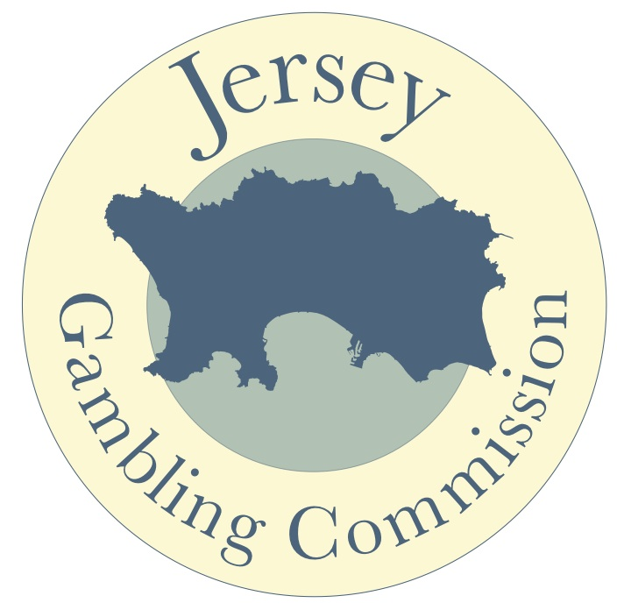

Policy Statement for the Conduct and Regulation of Social and Charitable Gambling

Published January 2013
Revised December 2016 & July 2019
Amended May 2022

JERSEY GAMBLING COMMISSION POLICY STATEMENT FOR SOCIAL AND CHARITABLE GAMBLING

The Jersey Gambling Commission (the Commission) regulates gambling promoted by clubs, societies and charities as fundraising to benefit good causes.

Gambling cannot be undertaken with the public for private gain. This policy is to allow for fundraising by charitable causes and bone fide local clubs and societies. Where individuals wish to raise money for a charitable cause (or club or society) that they are not a member of, they must ensure the beneficiary is aware. Individuals may not use gambling offerings to raise money without the knowledge and support of the beneficiary because this is a reputational risk to the good cause and also puts them at risk of being accused of acting fraudulently. Simply put, to ensure the public are not ‘conned’ by scammers, you must inform and receive the endorsement of the cause you wish to support BEFORE you proceed.

If you have any questions regarding this policy, please contact the Commission directly.

This document sets out the Commission’s policy for charitable gambling, its relevant permissions and appropriate enforcement. It is published in accordance with Article 9 of the Gambling (Jersey) Law 2012 and came into force on 1st January 2013.

Consultation
The Commission will consult on changes to its regulatory approach where it is appropriate to do so.

Decision making processes
The Commission will ensure that regulatory decisions are properly reasoned and evidence-based and undertaken in a timely manner.

Confirming licensing and regulatory decisions
The Commission will provide written notification of regulatory decisions, including:

- a clear explanation of the reasons on which the decision is based (in a level of detail proportionate to its impact); and
- details of any appeal mechanism(s).

The opportunity to make oral representations
The Commission will provide an opportunity for applicants to make oral representations to it in appropriate circumstances.

Minimum burden test
The Commission will ensure that its regulatory approach imposes the minimum burden necessary to promote the Guiding Principles. The Commission must take into account the regulatory impact on different types and sizes of applicant and ensure, without compromising key principles, it does not unduly hinder the activity.

Provision of information
The Commission will keep the sector fully informed of the requirements of the regulatory regime and provide general information, advice and guidance, both on request and on its own initiative, with a view to aiding compliance.

Complaints
The Commission will treat all complaints seriously and will address them in accordance with its complaints procedure.

Adopting a risk-based approach
The Commission will adopt a risk-based approach to regulation to ensure that its resources are concentrated where they are needed and can be most effective.

Proportionality
The Commission will generally use the least intrusive regulatory tool to achieve compliance and will ensure that any action is proportionate to the importance of the matters to which it relates, having regard to any risk assessment.

Publication of regulatory action
The Commission will publish details of any regulatory action taken, except where it considers that this may have a disproportionately damaging effect.

Gambling should be verifiably fair to consumers of those services.
The Commission must ensure that promoters of charitable gambling provide rules that are fair and clearly understandable.
It is a requirement for promoters to make public the results of events and competitions on which charitable gambling takes place.
The Commission will ensure that the Permits it issues, together with the conditions it imposes and the codes of practice it publishes, set appropriate standards of conduct for Permit holders, in connection with any permitted activity.
In the event of non-compliance, the Commission will ensure that conditions are imposed that deter future non-compliance on the part of the Permit holder.
It should be noted that non-adherence to the Regulations is a criminal matter and that any breach may be reported to and become the subject of a criminal investigation leading to prosecution.

Overview
There are 3 categories of ‘good cause’ gambling. These are based on how much the prize or prizes on offer are worth AND how often a club or society wants to use gambling to raise funds.

The 3 categories are:

Exempt
This category is for occasional or ‘one-off’ gambling promotions where the total value any prizes does not exceed £1500 and no more than 3 events (lotteries/raffles, bingo etc.) a year are promoted. More information on prizes appears later on in this policy.

Registered
This is the most common category as it deals with regularly held, small to medium scale fundraising using gambling promotions. If you use gambling to raise funds more than 3 times a year, or at any time offer prizes in excess of £1,500 but no more than £12,000, then you must register with the Commission.

The Commission will register a charity, club or society if it complies with the provisions of Regulation 5 of the Gambling (Charitable and Membership) (Jersey) Regulations 2012 (this is explained further on in this document). The Commission will refuse to register or revoke a Registration if it fails to comply with the provisions of Regulation 5.

Permit
A Permit is required if the value of prizes exceeds £12,000 per event.

The Commission will generally grant a permit to a charity, club or society if it complies with the provisions of Regulation 5 of the Gambling (Charitable and Membership) (Jersey) Regulations 2012. A grant will be conditional upon the applicant satisfying the Commission it has the knowledge, skill and understanding to conduct charitable gambling in compliance with the relevant conditions published in this document.

Types of Charitable Gambling
The types of charitable gambling generally allowed under a Registration or by Permit are:
- bingo
- lotteries (including raffles)
- cinema racing
- crown and anchor (when conducted by a licenced Crown & Anchor Operator); or
- other types of gambling expressly approved by the Commission.

The Commission also allows for the provision of online ticket sales. However, this permission can only be granted if the promoter can ensure that all ticket purchasers are all over 18 and Jersey residents. Please refer to the relevant chapter in Code of Conduct for Social and Charitable Gambling.

Refusals
The Commission will generally refuse applications, especially for a Permit, if the applicant:

- does not possess the knowledge and understanding to conduct charitable gambling,
- when an applicant having previously held a Registration or Permit, has not complied with the conditions attached to either of these permissions,
- there are circumstances to reasonably believe that approval would damage the charitable sector or not be in the public interest.

The types of gambling and the circumstances where the Commission will generally grant or refuse an application are set out in the Code of Practice for Social and Charitable Gambling. The Commission has a duty to promote good practice pursuant to Article 6 of the Gambling Commission (Jersey) Law 2010.
For applicants, the Code provides information on the conditions, standards and circumstances they must apply to charitable gambling. It explains the process of Registration and details the conditions placed on Permits.
The Commission uses these conditions and standards in the following ways:
- as a template for regulation,
- for the evaluation of applicants,
- as an audit for charitable gambling undertaken.
This statement will be reviewed from time to time and revised when necessary.

TABLE REFERENCE OF CHARITABLE GAMBLING BY TYPE AND CATEGORY
EXEMPT CHARITABLE GAMBLING | REGISTERED CHARITABLE GAMBLING | CHARITABLE GAMBLING BY PERMIT
A charity may hold gambling on a maximum of three days per year no matter what combination of gambling takes place. This means only 3 days in total NOT 3 days per type of gambling. | Where charitable gambling is in excess of the ‘exempt’ category, it must be registered with the Commission. | A charity must apply for and comply with the conditions of a permit when the prize fund limits exceed those allowed under a registration i.e. :-
A charity may hold 3 lotteries/raffles draws per year where the total prize fund is  £1500 (or less) per lottery. | More than 3 lotteries per year or any lottery where total prizes are between £1500 and £12,000. TOTAL prizes for the year may not exceed £30,000. | Lotteries/Raffles with total prizes over £12,000 per event, or over  £30,000 for the year.
Bingo played 3 times per year, where the total prizes are less than £1500 per session (24 hrs).  Or  A combination of lottery and bingo events (no more than 3 in total) where the prize fund does not exceed £1500, per event | Bingo organised & played regularly (more than 3 times per year) or any bingo with prizes greater than £1500 per session (24 hrs) and with a maximum of  £30,000 in total prize money in any one calendar year. | Any other gambling events (bingo etc) where the prize fund exceeds £12,000 for any ONE event or the TOTAL prize fund for the year is in excess of  £30,000.
IF IN DOUBT, PLEASE CONTACT THE COMMISSION BEFORE PROCEEDING WITH ORGANISING ANY GAMBLING EVENT. | You must submit a schedule of planned events prior to engaging in or promoting any registered charitable gambling. | Details of the draw mechanism, auditors and insurance, along with personal KYC are required to be submitted when applying for a permit.

In the event that a prize fund is generated in excess of the thresholds permitted the prizes may be distributed but the charity must submit a ‘unusual event’ declaration (downloadable from the Commission’s website) to the Commission as soon as possible and no later than 3 working days after the event. No further charitable gambling is permitted in such circumstances until authorised by the Commission.

IF A CHARITY HAS ANY DOUBT ABOUT WHICH CATEGORY A FUNDRAISING EVENT QUALIFIES FOR THEY SHOULD CONTACT THE COMMISSION.

Jersey Gambling Commission
4th Floor Osprey House
5-7 Old Street
St. Helier, Jersey, JE2 3RG
Tel: +44 (0)1534 828 540
Email: info@jgc.je
Web: http://www.jgc.je

